

**All About Cookies, IOS 14 Update, ITP’s , Ads Blocker and Server-side Tracking**

**What is Cookie**

Cookies are **small pieces of text stored in your web browser by a website you visit**.

**Types of Cookies**

1. **First Party Cookie -** First-party cookies are **directly stored by the website (or domain) you visit.** They help that website **remember information** about your visit, which can both make it easier to visit the **site again** and make the site more useful to you.

**For example:** Saving page navigation, cart information, user mail and pass to re-login smoothly etc..

1. **Third-Party Cookie -** Third-party cookies are stored in your browser by a third-party domain like the Advertising domain.

**For example:** Facebook, Google ads, Tiktok, Pinterest, Snap pixel codes

Some third-party cookies -

Facebook - _fbp & _fbc (6 months duration) used for retargeting and ads attribution

Google Ads - _gclid (3 months)

**IOS 14 Update**

**IOS 14 Update-** IOS 14 Update blocks any third-party cookie and shortens the cookie lifetime upto 7 days - 20 days or some high or less..

**ITP’s -** (Shortening the cookie life) IOS 14 Updates uses ITP’s

**Ads blocker -** Does not allow to drop third-party or marketing cookie in a website.

**Browser setting -** Also does not allow to store third-party cookies.

**Server-side tagging or tracking from server end**

This is how server-side tracking works with GTM

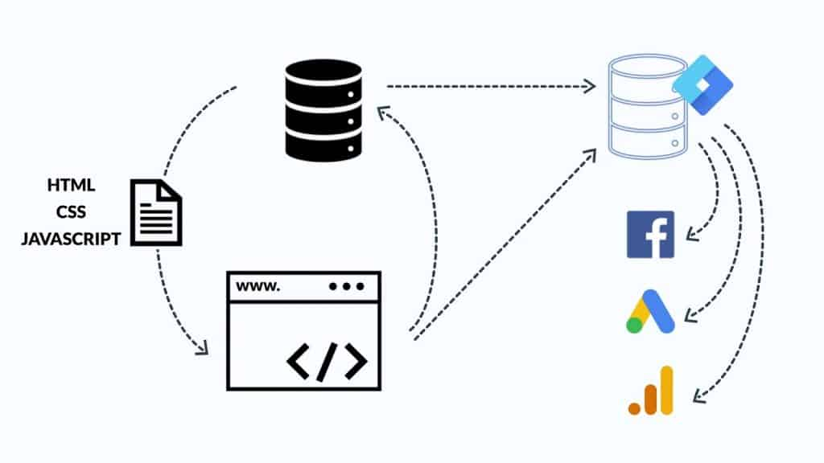

**Solution 1 -** Tracking from server end

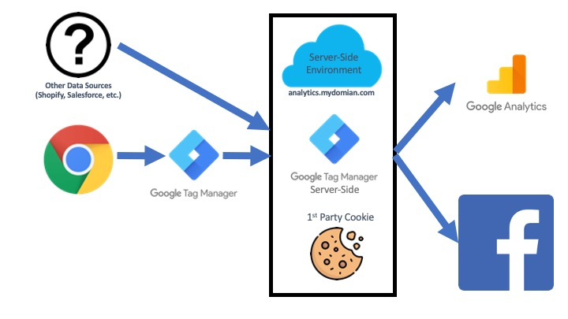

**Solution 2 -** Tracking based on first-party domain - tracking.dm-analyticsbd.com

**Server Cloud Setup**

1. **Stape server**
2. **Google Cloud Platform**

**Custom Domain setup in Stape server**

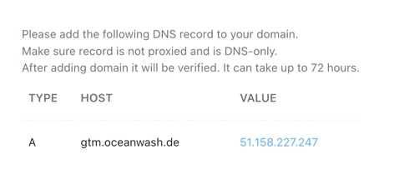

***Adding A record in DNS zone***

Please watch the video for details - <https://youtu.be/MIioRWyBkQE>

**Custom Domain in Google Cloud Platform**

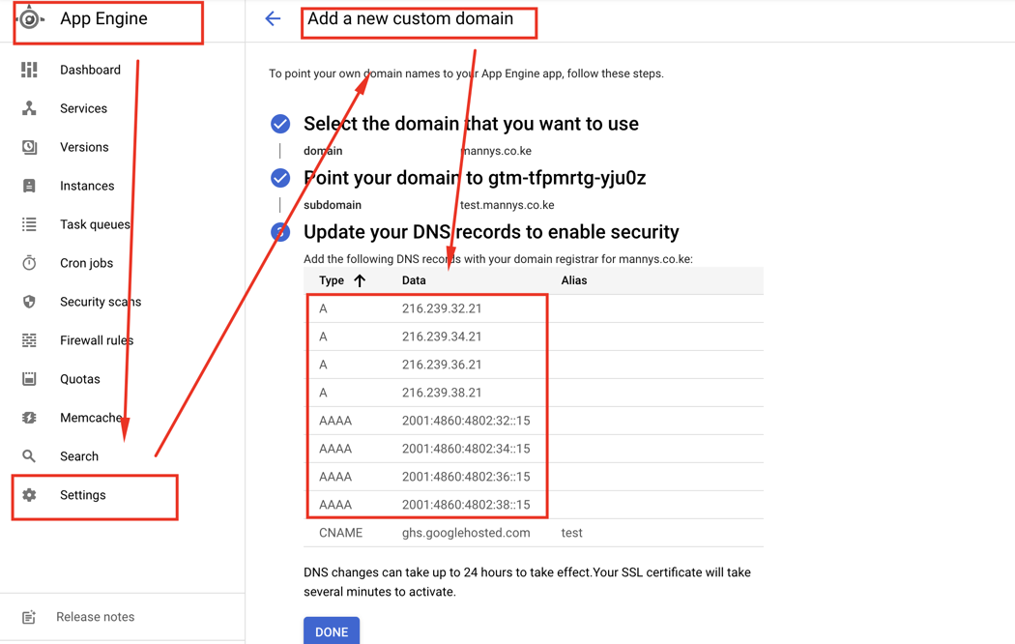

Please watch the video for details - <https://youtu.be/_e9O--0n9yg>

**Cookie life Extender -** To increase cookie life to prevent IOS 14 updates and ITP’s

Please watch the video for details - <https://youtu.be/3pywpYLkb0A>

Required Chrome Extension:

**EditThisCookie** - <https://chrome.google.com/webstore/detail/editthiscookie/fngmhnnpilhplaeedifhccceomclgfbg?hl=en>

App Engine Guide- <https://developers.google.com/tag-platform/tag-manager/server-side/app-engine-setup>